RESEARCHING PHOTOGRAPHIC COLLECTIONS

Historic photographs can be valuable for telling the history of a person or place. From photographs, researchers can determine aspects of the material culture, sociology, architecture, technology, industry and landscape of the past. Studied in conjunction with historical documents, oral interviews, artifacts and other sources, historic photographs can help establish the condition or appearance of an object, person or property during the historic period of significance. Individual photographs are useful records, and the information potential increases when a group or series of photographs are available, because they can show comparisons or changes over time.
Photographic Collections in Texas: a Union Guide, compiled by Richard Pearce-Moses (College Station: published for the Texas Historical Foundation by Texas A&M University Press, 1987), is the primary compilation of publicly accessible photographic collections in Texas. Local universities and colleges, museums, county historical commissions, heritage societies, governmental agencies and other entities may have historic photographs that will help you research a more comprehensive and accurate history.
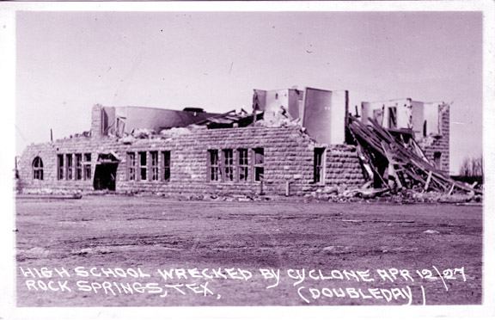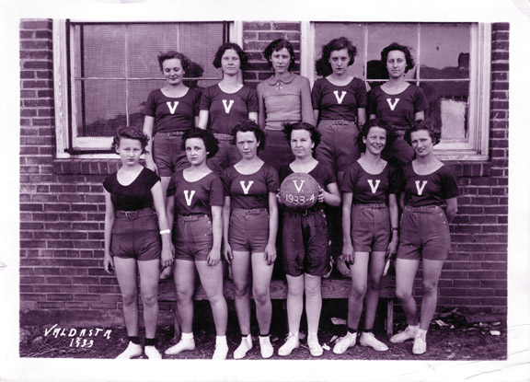
The images above show the kinds of information you can gather from historic photographs. On the left, a 1927 image shows tornado damage in Rocksprings, Edwards County. On the right, a 1933 image depicts the girls basketball team at Valdasta, Collin County.
Below is a partial list of major photographic collections in the state, grouped regionally. This is not a comprehensive list but is offered as an overview.
CENTRAL TEXAS
- http://library.austintexas.gov/ahc/photographs. Photograph Collection, Austin History Center, Austin.
- http://www.baylor.edu/lib/texas/. Texas Collection, Baylor University Libraries, Waco.

NORTH TEXAS
- http://library.uta.edu/collections. Photographic and Graphic Collections, University of Texas at Arlington Library, Arlington.
- http://texashistory.unt.edu/. The Portal to Texas History, hosted by the University of North Texas Libraries, Denton.

EAST TEXAS
- http://library.lamar.edu/services/university-archive/digital-archive/index.html. Christopher Negative Collection, Special Collections, Mary and John Gray Library, Lamar University, Beaumont.
- http://www.gthcenter.org/collections/photos/special1.htm. Photographic Collections, Galveston and Texas History Center, Rosenberg Library, Galveston.
- http://digital.sfasu.edu/. East Texas Research Center, Stephen F. Austin State University, Nacogdoches.

SOUTH TEXAS
- http://runyon.lib.utexas.edu/. Robert Runyon Photographic Collection of the South Texas Border Area, Center for American History at the University of Texas at Austin.
- http://www.cah.utexas.edu/exhibits/dodd/index.html. Jimmie Dodd Photographic Collection, Center for American History at the University of Texas at Austin.
- http://lhdatabases.cclibraries.com/archives/home.php. McGregor Photo Collection, Special Collections and Archives, Corpus Christi Public Libraries, and Corpus Christi Museum of Science and History, Corpus Christi.
- http://lib.utsa.edu/specialcollections/collections/photographs. Photo Archives, Library, Institute of Texan Cultures, San Antonio.
- http://vrhc.uhv.edu/photographs/. Victoria Regional History Center, Victoria.

WEST TEXAS
- http://libit.sulross.edu/archives/. Archives of the Big Bend, Sul Ross State University, Alpine.
- http://www.panhandleplains.org/. Panhandle-Plains Historical Museum, Canyon.
- http://www.cartermuseum.org/collections/smith/. Erwin E. Smith Collection, Amon Carter Museum, Fort Worth.
- http://swco.ttu.edu/photographs/index.php. Photograph Collections, Southwest Collection, Texas Tech University, Lubbock

STATEWIDE/OTHER LINKS
- https://www.tsl.texas.gov/search/node. Texas State Library and Archives Commission.
- http://www.lib.utexas.edu/taro/index.html. Texas Archival Resources Online.
- http://www.cah.utexas.edu/collections/photography.php. Photography Collection, The Center for American History at the University of Texas at Austin.
- http://www.hrc.utexas.edu/collections/photography/. Harry Ransom Humanities Research Center at the University of Texas at Austin.
- http://memory.loc.gov/ammem/index.html. American Memory, Library of Congress.

Texas Historical Commission
History Programs Division
P.O. Box 12276, Austin, TX 78711-2276
Phone 512/463-5853 Fax 512/475-3122
Email history@thc.texas.gov
www.thc.texas.gov

