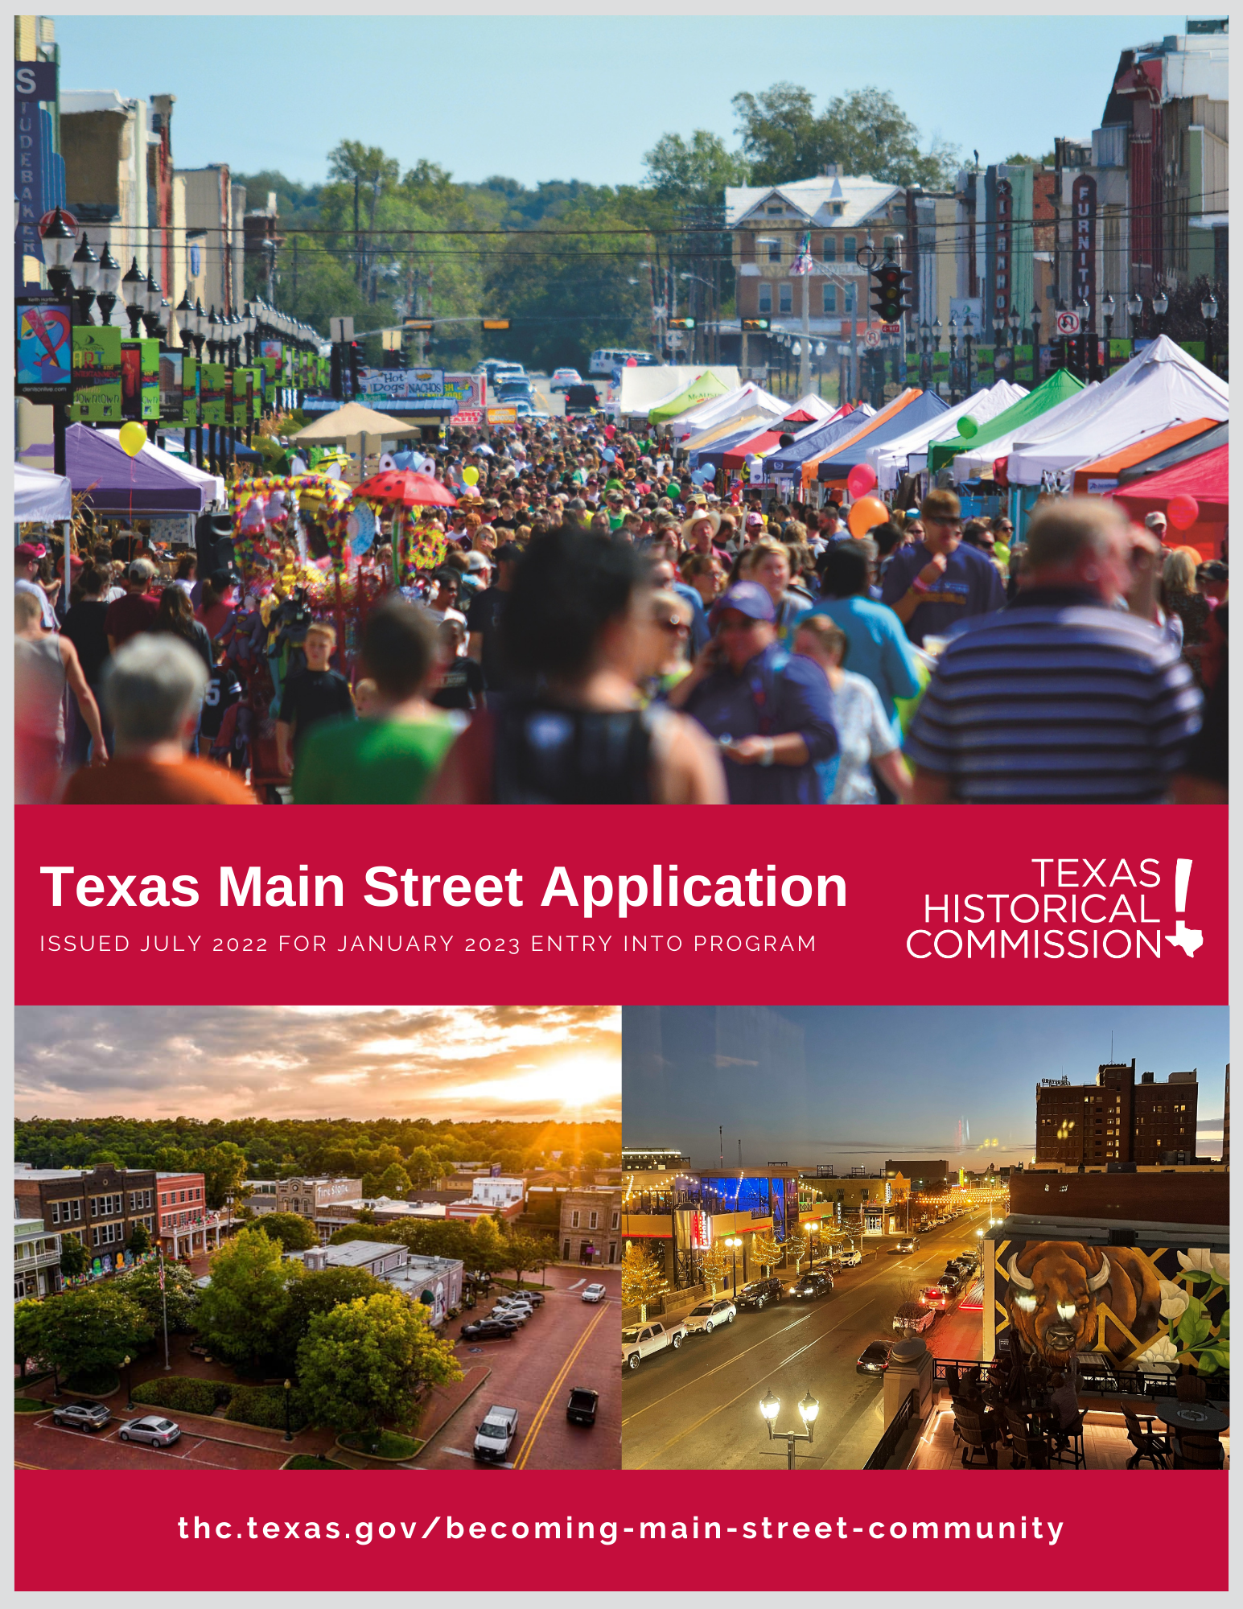

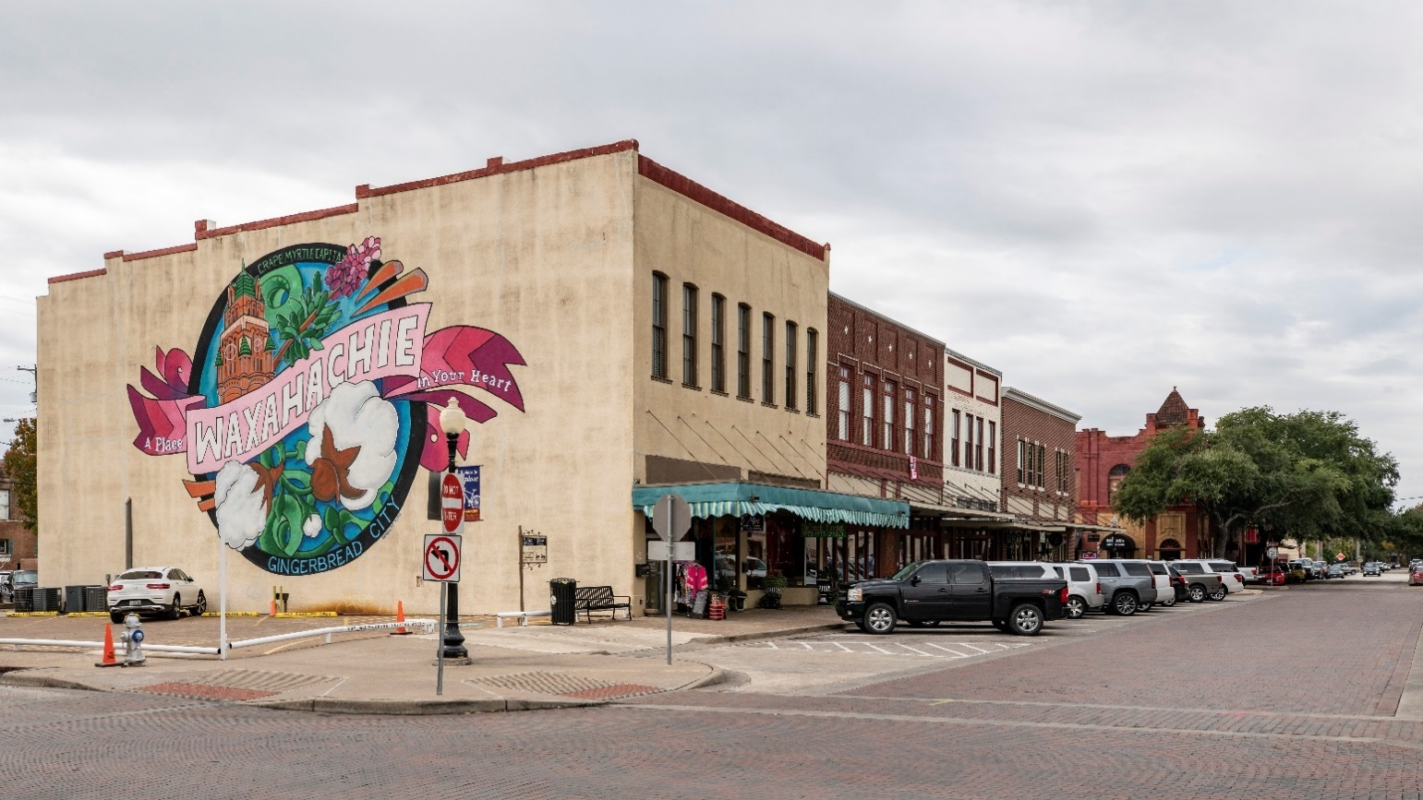
Cover images from Denison (courtesy of Donna Dow), Nacogdoches (courtesy of Jessica Sowell), and Amarillo; Waxahachie below.

TABLE OF CONTENTS––2023 Main Street Application

2022–2023 Main Street Application Timeline | 4
Application Introduction | 4
Application Checklist | 5
Application Submission Options | 5
Instructions for Maps and Digital Images | 6
Helpful Hints for Application Completion | 6
New Program Selection Criteria | 7
Current Map of Designated Communities | 8
Texas Main Street Program Intent to Apply Form | 9
Texas Main Street Program Application*  - Official Certification  - City Data and Government Profile  - Community Partnership Data  - Criterion I Data: Historical commercial fabric and historic character  - Criterion II Data: Community and private sector support and organizational capacity  - Criterion III Data: Support and financial capacity  - Criterion IV Data: Physical capacity and business environment  - Criterion V Data: Demonstrated need | 10
Sample Resolutions (text provided for your use)
Sample Budgets (provided separately in an Excel document)

*The cells in this document are set to expand as you insert text. To avoid confusion, numbering for this Table of Contents stops at first page of application data entry.

2022-2023 TIMELINE

July 15, 2022 | Optional Intent to Apply due date. Intent to Apply does not obligate an application. Form is page 9 of this packet.
July 29, 2022 | Applications due to Texas Main Street Program (TMSP) office by 5 p.m.
October | Approval of new cities during Texas Historical Commission quarterly meeting,
November | Formal announcement of new Main Street communities.
November−December | TMSP staff consult with new applicants on manager hires and local program creation.
January 1, 2023 | Official start date for new 2023 Main Street cities!  Managers and board members start date for service and training.

INTRODUCTION
The Texas Main Street Program (TMSP) is a part of the Community Heritage Development Division of the Texas Historical Commission (THC). Each year, Texas cities or neighborhood commercial districts may apply for official Main Street designation. As a trademarked program under the National Main Street Center, a community or district may not call itself “Main Street” nor may it employ a “Main Street Manager/ Director” without an application and official designation by the TMSP and THC.
This document is the official application to request entry into the Texas Main Street Program. Administrative rules for eligibility and compliance can be found in the Texas Administrative Code, Title 13, Part 2, Chapter 19. Types of applicants are described below.
- Texas Main Street Small City: Communities with a population of 50,000 people or fewer. Applications from this Small City category should reflect the local program being organized under city government. Once accepted, cities must employ a full-time Main Street manager as a city employee and commit to operate the program for at least three years.
- Texas Main Street Urban City: Communities with a population of 50,001 people or greater. Once accepted, an Urban City program must employ a minimum of two full-time dedicated staff and commit to operate the program for at least five years. This sized local program can be organized under either of the following models and the application must specifically show how the urban model selected is the best fit for the local program:
  - A stand-alone non-profit organization with a governing board under which the Main Street manager/ assistant are employed. In this model, the city provides a portion of program funding and other support.
  - Part of city government, in which the program manager/assistant are paid employees of the city, with a volunteer Advisory Board to provide volunteer support, additional fundraising, and advocacy for the local program.
- Texas Main Street Recertified City: Communities formerly in the program, any population. Once accepted, the Recertified City must follow the Small City or Urban City models above including the staffing and minimum commitment period.
The hiring process for a Main Street manager should not commence until after the Commission of the THC votes to accept new programs at their fall quarterly meeting, which usually occurs in October. An applicant may already have in place someone whose job title reflects downtown work, such as Downtown Director, Downtown Coordinator that will transition into Main Street manager, but it is not required.
APPLICATION CHECKLIST
- Intent to Apply (see page 9). Submit the Intent to Apply form through mail or by emailing the State Coordinator.
- One application includes the following. Submission format instructions below.
  - Applicant Information.
  - Completed application provided in this packet.
  - Supplemental information. Additional information demonstrating community support, such as newspaper articles, public meeting notices, etc., may be submitted.
  - Resolution. From the city government or, if an urban application, a resolution from both the city and the advisory organization if applicable. Sample resolutions are in this packet. Submit signed resolutions with the application.
  - Budget. A proposed budget must be included with your application. Sample budgets are in this packet.
  - Maps. Instructions for map detail and type are provided on Page 6 of this packet.
  - Optional documentation. Applicants are asked to provide copies of central business district building inventories and downtown master plans if documents exist.
- Provide one set of the following
  - Twenty-five (25) JPG images. Images show evidence of a consistent amount of historic commercial buildings in the proposed Main Street Program area. DO NOT put images in a PowerPoint™ format. Review instructions that follow for submitting digital images, including specific required images.
  - Narrative for images. The narrative should be concise but still tell a story that explains the history of your town and provides information about the current state of downtown. Do not include in the narrative names of individual business/building owners unless they are historically significant or otherwise relevant (i.e., the person owns multiple buildings in the program area etc.).
  - Letters of support. Letters should demonstrate support for the Main Street Program from all segments of the community––merchants, civic and historical organizations, and citizens. Form letters are discouraged.

APPLICATION SUBMISSION OPTIONS
Option 1: Mailed hard copy. Submit one master completed application with all required information to the following address as applicable. For mailed applications, the required 25 JPG images will be submitted on portable storage device such as CD or flash drive and will be included in the mailed packet.
U.S. Postal Service Mail:  Texas Historical Commission  Community Heritage Development Division  Texas Main Street Program  ATTN: Amy Hammons, State Coordinator  P.O. Box 12276  Austin, Texas 78711-2276 | Hand Deliver or Courier Service:  Texas Historical Commission  Community Heritage Development Division  ATTN: Amy Hammons, State Coordinator  1304 Colorado St.  Austin, TX 78701  512-463-6092

Option 2: Digital submission. Provide all required application information and 25 JPG images through a file sharing site (i.e., Google Drive, Drobox, etc.) and email the application’s weblink to the Community Heritage Division Office Manager, Kimberly Klein, via kimberly.klein@thc.texas.gov. Please call 512-463-6092 if you do not receive an email confirmation of application submission from Kimberly.
Reminder: Deliver completed applications to the TMSP office via email, mail, or hand-delivery no later than
5 p.m., July 29, 2022. Applicants must manage varying delivery timelines regardless of submission option selected.
INSTRUCTIONS FOR MAPS AND DIGITAL IMAGES
- Map 1: Proposed Program Area. This section must include a map outlining the proposed program area. THC website provides general comments on determining your Main Street district (program area). Indicate on this map all local or National Register historic districts, special local zoning overlays, and any economic development districts, such as a Tax Increment Reinvestment Zone. Submit this map with the application and submitted with the Intent to Apply (page 9).
- Map 2: Supporting Images Noted in Narrative. Map should be marked to identify the images presented in the narrative described in the Application Checklist (page 5) and must illustrate your program area’s cohesive historic fabric. Applicants may use Google Earth™ and Google™ Maps.
- Images should document not only need for Main Street support, but also a city’s ongoing commitment to, and investment in, downtown resources. These efforts illustrate the city’s potential to be a successful as a Main Street program. Present images with and without people.
- In addition to overall shots, include a few images of important individual structures in the proposed program area (post office, courthouse, city hall, banks, department stores, etc.) Also include some significant resources from outside the program area (college campuses, or historic agriculture/industrial sites) to show broader context for downtown. Views of empty lots or urban parks should be shown as they relate to the downtown buildings.
- There may be a unique residential neighborhood within walking distance of the proposed program area. If so, describe briefly in narrative with images that are representative of the whole neighborhood rather than taking excessive shots of individual houses. Remember, Main Street is a commercial revitalization program.
- Choose images with care––selecting inferior quality/low resolution images reflect poorly on an application, as do images that do not adequately show evidence of historic commercial fabric.
- Title each JPG image with the city name and a number⎯CityName-01.jpg⎯which will correspond to the submitted narrative. Provide only JPG images. DO NOT present the images in a PowerPoint™ presentation.

HELPFUL HINTS FOR APPLICATION COMPLETION
- Use the APPLICATION CHECKLIST to ensure that all required items are submitted. Review the final draft of your application to ensure that your answers address all SELECTION CRITERIA considerations.
- Adhere to application format and keep responses brief while providing complete information.
- The proposed Main Street program area should be the well-defined traditional, historic commercial core of your community. Select the area that has the strongest concentration of historic commercial buildings.
- Applicants must demonstrate a commitment to participate actively in the TSMP network for the minimum of three years for Small City applicants and five years for Urban City applicants. Convey intent to develop a sustainable effort beyond 3–5 years through incremental progress over time, achieving short- and long-term goals. A third of communities in the TSMP network have been active for 20+ years, and we hope that number grows.
- Applicant commitment is demonstrated by efforts to attract a qualified program manager. Proposed budget can include a competitive manager salary, employee benefits, and stable program funding. The budget should also include funds for professional development and related travel expenses, which are required for the program manager. FYI⎯While fundraising and grant writing are often part of a program’s work plan, Main Street leadership should not expect the manager to raise funds that are used for the sole purpose of sustaining the program. Fundraising revenue and grant monies typically are directed towards special projects.
- The application requires information from a variety of sources.
- For population/demographic information, visit the U.S. Census Bureau (census.gov) to find American Fact Finder, Quick Facts and Population Finder. Access the Texas State Data Center/Office of the State Demographer at osd.texas.gov.
- For unemployment data, visit the Texas Workforce Commission at twc.state.tx.us.
- For sales tax data, visit the Texas Comptroller of Public Accounts (comptroller. texas.gov). Some information can be obtained through Council of Governments for your area (txregionalcouncil.org). If available in your town, you may also gather data by contacting city economic development or planning departments, the economic development corporation, or the chamber of commerce.

NEW PROGRAM SELECTION CRITERIA
Completed applications are evaluated independently by members of the Main Street Interagency Council, comprised of representatives from Texas Main Street staff and various state agencies. Each reviewer’s score is averaged, creating a Council ranking and recommendation.
At their fall quarterly meeting, the governor-appointed members of the Texas Historical Commission make the final decision regarding cities to be designated as official Texas Main Street programs. The Commission will not accept an applicant community that score 70 or below in the evaluation. The Commission still has discretion of whether to approve those applicant cities with scores above 70. Up to five cities of any population size may be selected by the Commission, subject to available resources.
Applications are reviewed using the following criteria resulting in a maximum potential score of 110 points. Each section of the application is divided into these categories although the evaluators may consider all the information provided in that application, regardless of its placement by applicants.
- Historic commercial fabric and historic character: Criterion considers the amount of historic fabric in the proposed Main Street area, as well as the historic significance of district (as a whole) and individual buildings. Criterion also considers a city’s demonstrated interest in, and commitment to, historic preservation. (Questions 20-27 and images, 35 points)
- Community and private sector support and organizational capacity: Criterion considers viability of applicant successfully implementing the Main Street program. How well does applicant illustrate a breadth of organizational, financial, in-kind, and volunteer support for the program? (Questions 28-33 and letters of support, 25 points)
- Support and financial capacity: Criterion considers the applicant’s financial capability to employ a full-time manager, fund a local Main Street program, and support downtown-related projects. (Questions 34-37, resolution and proposed budget, 24 points)
- Physical capacity and business environment: Criterion considers the degree to which the application conveys the cohesiveness, distinctiveness, and variety of business activity conducted in the proposed Main Street Program area. (Questions 38-43 and images, 10 points)
- Demonstrated need: Consider statements related to the city’s need for the Main Street program. (Questions 44-48 and images, 10 points)
- Geographic distribution and discretionary consideration: An application from a county in which there are no currently designated Main Street programs receives an additional three (3) points; the next page provides a map of existing Main Street communities. Additionally, a scoring committee member may give up to three (3) additional points to signify notable representation of need, preservation or economic development effort, or financial capacity that goes beyond the minimum requested in the application. The member will provide a rationale for these extra points. (No specific application section or questions, 6 points total.)
2022 TEXAS MAIN STREET CITIES
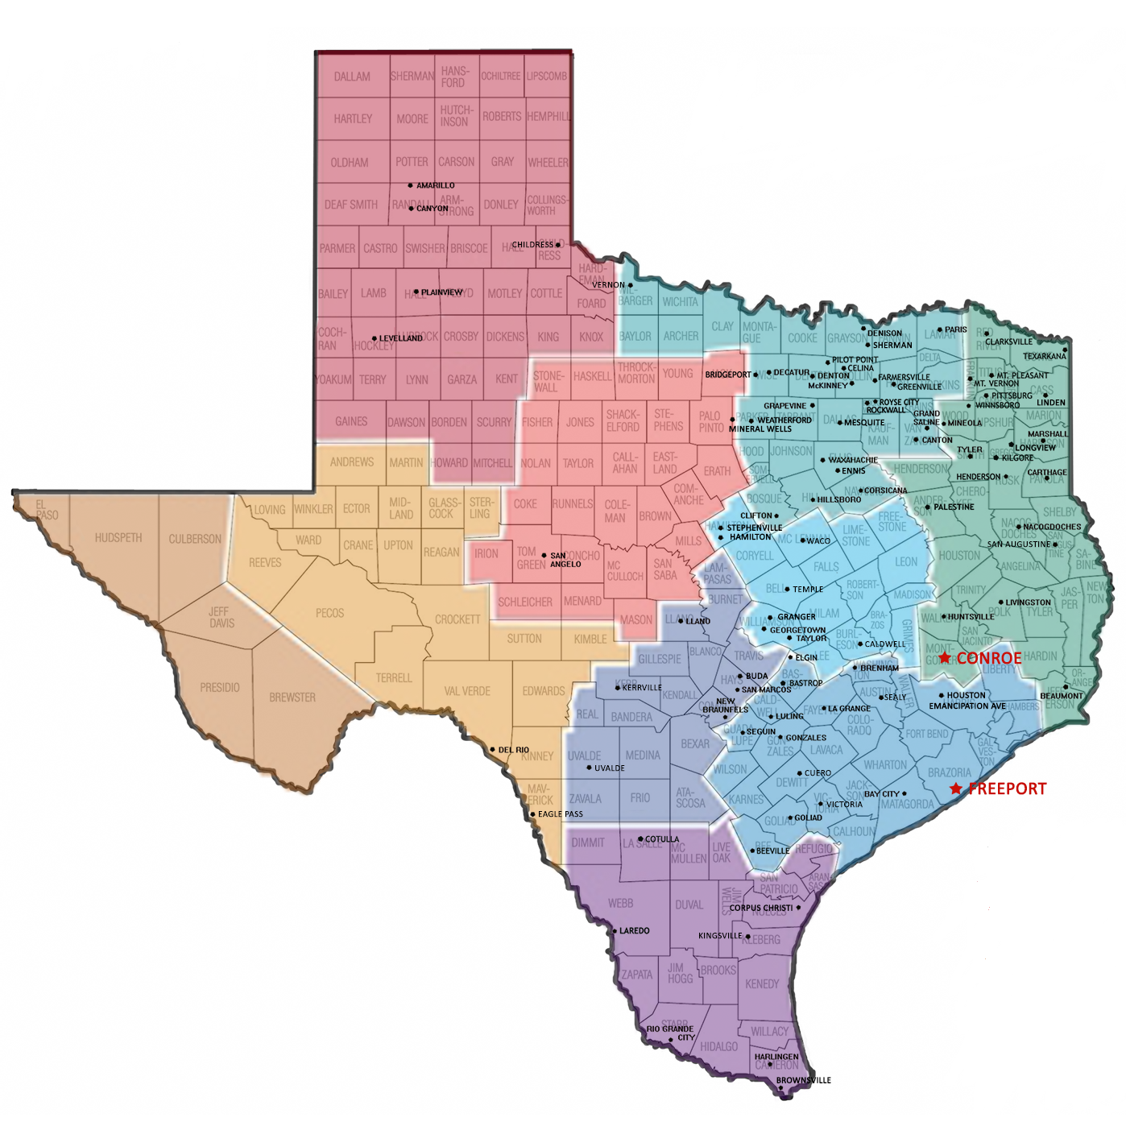

Note: Red-starred communities are most recent cities to enter the statewide network. Visit the Texas Historical Commission website (thc.texas.gov/preserve/projects-and-programs/texas-main-street/current-participants) to earn more about the statewide network of Texas Main Street communities.

INTENT TO APPLY to the Texas Main Street Program (for entry January 2023)

Submitting this form is OPTIONAL. Mail/email to Texas Main Street Program (TMSP) office by July 15, 2022.

Community Intending to Apply
Small City or Urban City designation?
Note if this is a Recertified City
Date of Form Submission

Main Street applicants enter the TMSP program with oversight from a governmental structure or nonprofit organization. Specify primary oversight intended and primary authority figure designated if city is selected.
City or Nonprofit Oversight?
Name of City or Nonprofit
Name of Official or Director
Official/Director Title
Full Address
Telephone Number
Email Address
Official/Director Signature

Provide contact information for individual preparing this form if different than person noted above.
Name of Preparer
Title
Organization
Full Address
Telephone Number
Email Address
Preparer’s Signature

MUST include map of proposed Main Street program area; see page # for more information on map requirements.

2023 TEXAS MAIN STREET PROGRAM APPLICATION

Completed application must be received by Texas Main Street Program (TMSP) office by June 29, 2022. Digital signatures are acceptable. Type directly into this questionnaire and use whatever space necessary to provide complete answers. Cells should expand to accommodate the text you enter.

List City and County
Community Label | New City ☐ Recertified City ☐
Applicant Type | Small City ☐ Urban City ☐
If Urban, specify governance. | A stand-alone non-profit with city support ☐  A city department with an Advisory Board ☐

Primary contact/name of person preparing application
Preparer’s Signature

Title
Organization
Full Address
Telephone Number
Email Address

Name of City Manager
Full Address
Telephone Number
Email Address
Name of State Senator
Full Address
Telephone Number
Email Address
Name of State Representative
Full Address
Telephone Number
Email Address

MAIN STREET APPLICATION OFFICIAL CERTIFICATION
The City of [INSERT CITY NAME] endorses the submission of this application and agrees to participate in the development of the local Main Street Program.
Name of Mayor
Mayor’s Signature

Full Address
Telephone Number
Email Address
(The following statement/contact information is for Urban/Nonprofit applicants only.)

The Board of [INSERT NONPROFIT NAME] endorses the submission of this application and agrees to participate in the development of the local Main Street Program.
Name of Board President
President’s Signature

Full Address
Telephone Number
Email Address
Note: The urban contract requires a full-time manager and assistant dedicated to the Main Street effort. If submission is from a stand-alone non-profit and the organization’s membership area is larger than the Main Street district, please explain in the application how the Main Street manager will dedicate all his/her time to the Main Street effort. (i.e., the manager is part of a larger staff and others handle the duties of the rest of the membership area.)

CITY DATA AND GOVERNMENT PROFILE
Cells will expand to accommodate applicant text.
1. City population 2020 census Current estimate
2. County population 2020 census Current estimate
3. Provide ethnic breakdown of the city’s population with amounts totaling 100%.
Anglo % African American % Hispanic %
Native American % Asian and Pacific Islander % Other %
4. Local unemployment rate Size of local labor force
5. City’s revenue from general sales tax (by fiscal year):
FY 2021 (or last complete FY) FY 2022 or current (partial FY)
6. Revenue from hotel occupancy tax:
FY 2021 (or last complete FY) FY 2022 or current (partial FY)
How is this funding used?
Click or tap here to enter text.

7. List the largest employers in the city and extraterritorial jurisdiction.
Names of employers Number of employees

8. Explain how economic development is approached in your community.
  - Has your city elected to levy the additional sales tax for economic development? Yes ☐ No ☐
If no, has maximum taxing capacity been reached?
Yes ☐ No ☐ (combined total state/local taxes of 8-1/4 % -.0825)
If yes, what is the type:
Type A ☐ Type B ☐ Both ☐ Municipal Development District ☐
What is the rate? What is the yearly revenue?
How is it used?
Click or tap here to enter text.

  - Are there other groups specifically involved in community-wide economic development (i.e., a private economic development foundation or partnership group, a chamber of commerce economic development team)?
Yes ☐ No ☐
If ‘yes,’ please describe:
Click or tap here to enter text.

- Please check what exists in your community.
☐ Planning and zoning commission
☐ Planning and zoning department and/or staff. If yes, staff size?
☐ Tax Increment Reinvestment Zone that includes the Main Street Program area.
☐ Overlay or special zoning district that includes the Main Street Program area.
☐ Building inspector(s). If yes, staff size?
☐ Building code If yes, date approved?
Which code? Most recent update?
Date of last Comprehensive Plan update?

- a. Does city have a central business district inventory of buildings?
Yes ☐ No ☐ Date inventory last updated

b. Does city have a downtown master plan?
Yes ☐ No ☐ Date master plan approved

What efforts has the city made to implement the plan?
Click or tap here to enter text.

If inventory and/or master plan exists, please attach a copy of document/s to your application submittal.

- If the city does NOT have a formal plan, does it have policy priorities for solving the problems of the central business district?
Yes ☐ No ☐
If so, what are the priorities?
Click or tap here to enter text.

- Please note projects undertaken in the last 5 years to address streets, sidewalks, drainage, utilities, or other infrastructure in the central business district.
Click or tap here to enter text.

- What is your city’s bond rating?
Is there an active Capital Improvement Program/Plan (CIP) presently? Yes ☐ No ☐
If ‘yes,’ please describe the primary project types and any of the CIP projects downtown?
Click or tap here to enter text.

- What will be the primary sources of funds for the salary and other expenses of the Main Street program? (This will also be noted in the budget proposal.)
Click or tap here to enter text.

COMMUNITY PARTNERSHIP DATA (note if no such organization exists)
- Chamber of Commerce: Describe the chamber’s budget, membership/staff size, primary areas of focus, and if the chamber committees or activities focus on downtown.
Click or tap here to enter text.
16. Downtown or Merchants/Business Association: Describe the association’s budget/sources of funding, membership/staff size, and its major activities.
Click or tap here to enter text.
- Convention and Visitors Bureau: Describe the bureau’s budget, membership/staff size, and if any bureau committees or activities focus on downtown.
Click or tap here to enter text.
- Local Heritage Organization (citywide)/Arts Organizations: Check box if type of organization exists.
☐ Local heritage society (non-regulatory) or a preservation-related nonprofit
☐ Local or regional arts council
☐ County Historical Commission that is active in our community
☐ Other. Please describe below.
Click or tap here to enter text.

- Is your community a county seat? Yes ☐ No ☐

MAIN STREET APPLICATION CRITERION I
Historic commercial fabric and historic character: The historic significance/fabric of the proposed Main Street area and the interest in and commitment to historic preservation.

Note: This information should be available locally; some information requested in question 20 is also available through the Texas Historical Commission’s Atlas at thc.texas.gov.

20. Check the box if properties in your community have the item listed (one or multiple).
☐ Individual properties listed in the National Register of Historic Places (NR)
☐ NR districts (NR district)
☐ Recorded Texas Historic Landmarks (RTHL)
☐ Local historic designation program (Local)
From items checked above, please name individually the historic properties and districts within the proposed Main Street program area and label type as noted above in parentheses. Either include in the text box below or provide list on a separate sheet and attach to your application submission.
Click or tap here to enter text.

21. Does your municipality have the following preservation organization, program, or tool?
Landmarks or Historic Preservation Commission Yes ☐ No ☐ In progress ☐
Historic preservation ordinance Yes ☐ No ☐ In progress ☐
Design review board/process Yes ☐ No ☐ In progress ☐
Certified Local Government Program Yes ☐ No ☐ In progress ☐
Historic preservation incentives Yes ☐ No ☐ In progress ☐
(i.e., tax abatements, fee waivers, grants, etc.)

22. What is the approximate age of the existing building stock in the proposed Main Street program area? Estimate by percentage with all numbers adding up to 100%.
pre-1860 = % 1860-1879 = % 1880-1899 = % 1900-1919 = %
1920-1939 = % 1940-1963 = % post-1963 = %
23. Discuss changes over the past five years (or longer)—positive and negative—to the proposed program area’s historic fabric, which includes the buildings (materials and features), plazas, landmarks, etc. that are of historic significance. Note the reason for these changes and their effects on how the community’s historic fabric. For example, note if your city went through a major development that changed the historic grid, resurgence of industry that brought about more modern construction downtown, suffered a tornado that destroyed historic buildings downtown, or government offices moving out of downtown, etc.
Click or tap here to enter text.

24. Please discuss projects to preserve cultural and historic resources that have taken place throughout your city during the past five years. This work could include the restoration or rehabilitation of a historic building; landmarks or landscapes; the preservation of other sites; heritage festivals or events; and oral histories. Also comment on the preservation projects that your community and/or organization plans to undertake in the next 2 years.
Click or tap here to enter text.

25. What heritage tourism efforts has your community undertaken to attract visitors to your downtown and/or local historic sites?
Click or tap here to enter text.

26. Does your community feature local history and/or historic sites in branding or marketing efforts? If so, how?
Click or tap here to enter text.

27. To what degree your community has been active in Texas Historical Commission (THC) initiatives? Community includes the local government, a local business, or a local property owner, or specific community member. Check the activity in which your community is active and provide details in the text box below.
☐ Efforts to designate properties as historic (National Register, Recorded Texas Historic Landmark, State Antiquities Landmark)
☐ Initiating and/or maintaining historic resources surveys
☐ County applied for funding through the Texas Historic Courthouse Preservation Program
☐ Recipient of a Texas Preservation Trust Fund grant
☐ Applied for historic preservation tax credits
☐ Volunteered with a THC Historic Site (or its Friends group)
☐ Secured a Texas Treasure Business Award for a local business
☐ THC Awards Program winner (individual awards)

Click or tap here to enter text.

MAIN STREET APPLICATION CRITERION II
Community and private sector support and organizational capacity: Demonstrates community and private sector support for the program as well as the capability of the applicant to successfully implement the Main Street Program.

28. To be successful, a Main Street program requires wide buy-in and support. How have you informed downtown stakeholders and community groups about the Main Street Program? Who has been involved in promoting public awareness of Main Street? Please reference newspaper articles, social media, or supplemental material. Skip if you have not informed your community.
Click or tap here to enter text.

29. To whom will the local Main Street manager report––name and title?
Click or tap here to enter text.

30. List the three most important goals for your program.
1.

2.

3.

How did you arrive at these goals? Who contributed to these discussions/decisions?
Click or tap here to enter text.

31. Has the private sector demonstrated interest and support for revitalization of the Main Street Program? List specific activities and projects undertaken in the Main Street program area during the past two years by the private sector. Give a brief description of the scope of these activities, projects, or programs and summarize the applicability to, and the potential impact of, these activities, projects, and programs on downtown.
Click or tap here to enter text.

32. Briefly describe efforts that demonstrate commitment to revitalization, such as spearheading the creation of special assessment districts or tax increment financing projects, the development of financial assistance programs or other similar activities.
Click or tap here to enter text.

- Provide information on local financial institutions.
  - How many financial institutions are there in the city?
  - How many financial institutions are in the Main Street program area?
  - Indicate if financial institutions have made a commitment in support of the Main Street program and/or invest in downtown revitalization, such as establishing low-interest loan pools or incentive grant funding? Note how much funding was pledged and at what interest rate (loan pool).
Click or tap here to enter text.

MAIN STREET APPLICATION CRITERION III
Support and financial capacity: Demonstrate the financial capability to employ a full-time manager, fund a local Main Street Program and support downtown-related projects.

- Consideration under this criterion includes a resolution of support; templates provided in this application.
☐ Yes, we are attaching a signed resolution to this application submission
☐ No, we were not able to secure a signed resolution

- Consideration under this criterion includes a proposed budget for your program. Use the Excel document of budget templates and samples to provide your budget data. Attach completed budget to this application submission, either as an Excel spreadsheet or a .pdf document.
☐ Yes, we are attaching a completed budget to this application submission
☐ No, we do not know how the proposed program will be funded

36. Answers to the following questions should include comments on how efforts will encourage historic preservation efforts in downtown.

a. In addition to providing funding the program, describe how the public sector will be involved in the local Main Street Program––additional funding, incentives, in-kind support, etc.
Click or tap here to enter text.

b. How will the private sector support/contribute to the local Main Street program?
Click or tap here to enter text.

37. What efforts have been made to attract or retain business in the central business district?
Click or tap here to enter text.

MAIN STREET APPLICATION CRITERION IV
Physical capacity and business environment: The cohesiveness, distinctiveness and variety of business activity conducted in the proposed Main Street Program area.

38. Please provide information about your proposed Main Street district.
a. How many blocks are in the proposed program area?
b. How many buildings are in the proposed program area?
c. What is the average daily traffic count at the center of your district along its primary street?

- Provide information about businesses in your proposed Main Street district.
a. What is the total number of businesses in the proposed program area?
b. Of these businesses, how many also own the building in which they are operating?

40. Use the table below to list the number of spaces, amount of square footage and percentage of square footage devoted to each use in the proposed program area. Estimates are acceptable.
Taxable Usage | Number of Spaces | Square Footage | % Square Footage
Retail/Commercial
Industrial, Manufacturing, Warehouse
Office and Professional Services
Personal Services
Lodging
Residential
Restaurants and Bars
Arts and Entertainment
Storage
Vacant
Non-Taxable Usage | Number of Spaces | Square Footage | % Square Footage
Religious, Nonprofit, Government, Institutional
11 categories above; percentages in far-right column should add up to 100% |  |  | = 100%

- Provide the following information about your proposed district.
- Number of buildings that have vacant ground floor storefronts?
- Number of buildings that have entirely vacant upper floors or upper floors that are used only for storage?
- Number of buildings that are entirely vacant buildings–both ground floor and upper floors?
- Number of vacant lots in your proposed district?
- Number of commercial spaces for lease?
- Number of buildings for sale?
- Number of the occupied storefronts, what percentage are currently used for retail? %
- Total number of jobs/employees in the proposed program area?
- Total number of residential units in the proposed program area?

42. Discuss the characteristics that make the proposed Main Street program area a cohesive and recognizable business district.
Click or tap here to enter text.

- Describe retail competition your downtown faces from nearby shopping centers, malls, etc.
Click or tap here to enter text.

MAIN STREET APPLICATION CRITERION V
Demonstrated need: The need for the Main Street Program. Include and explain your greatest challenges.

44. Why are you applying to become a Main Street city––what can you accomplish through a Main Street program that you cannot accomplish on your own?
Click or tap here to enter text.

45. Have you sent a delegate of city leaders to visit a neighboring Main Street community to better understand the program’s structure? If so, what community did the delegate visit and when? Skip if you did not make a visit.
Click or tap here to enter text.

- Describe the condition of your proposed Main Street district.

- Describe the physical condition (good and bad) of your proposed Main Street program area, including historic buildings and public spaces.
Click or tap here to enter text.

- Discuss the local capacity to properly maintain and improve the historic buildings, to handle downtown design issues, and to address vacancies and blight.
Click or tap here to enter text.

- Provide comments on business conditions considering the previous question’s answers.

- Discuss the strengths and needs of the proposed Main Street program area as related to businesses and business mix, and to competing shopping destinations.
Click or tap here to enter text.

- Describe trends in the proposed Main Street program area relating to the economic environment such as business openings and closings in the last five years.
Click or tap here to enter text.

48. If applying for RECERTICATION, please address the following. Skip if you are a new city applicant.

a. The timeframe your community was previously in the program.
Click or tap here to enter text.

b. Why was the local program disbanded previously.
Click or tap here to enter text.

c. Why the current environment and timing is more appropriate now to re-enter the Texas Main Street network and sustain an active and successful program.
Click or tap here to enter text.

SAMPLE RESOLUTIONS
URBAN, SMALL CITY, AND RECERTIFICATION

TMSP provides the following sample resolutions for your use. You may want to modify to a certain degree as is appropriate for your community; however, remember to maintain language that conveys a sincere commitment to pursuing a local Main Street program in your community.

SAMPLE RESOLUTION TEXT FOR CITIES WITH POPULATION OF 50,000 OR FEWER

A RESOLUTION AUTHORIZING PARTICIPATION IN THE TEXAS MAIN STREET PROGRAM AND DESIGNATING THE CITY MANAGER TO COORDINATE PROGRAM ACTIVITIES.

WHEREAS: The Texas Main Street Program of the Texas Historical Commission has been authorized to assist historic commercial areas in cities with population of 50,000 people or fewer to develop a public/private effort to revitalize their target areas. If selected, this historic commercial area will begin participation in the Texas Main Street program in January 2023.

NOW THEREFORE BE IT RESOLVED BY THE CITY COUNCIL OF THE CITY OF

SECTION 1. That the City of plans to apply for selection to participate in the 2023 Main Street program with the specific goal of revitalizing the central business district within the context of the preservation and rehabilitation of its historic buildings.

SECTION 2. That the City of will provide an adequate budget to employ a full-time Main Street program manager for a minimum of three years, fund training of the Main Street Program manager, cover operating expenses of the program, and ensure that initiatives assigned by the City to Main Street have access to the human and fiscal resources required for success.

SECTION 3. That the City Manager (or state designee) be designated to supervise the Main Street manager activities. PASSED, APPROVED, AND ADOPTED THIS day of , 2022.

[Provide signatures below; digital signatures are acceptable.]

ATTEST: APPROVED AS TO LEGAL FORM:

CITY SECRETARY CITY ATTORNEY

SAMPLE CITY RESOLUTION TEXT FOR GOVERNMENT URBAN APPLICATION
Note: This resolution will vary depending on whether the program is to function under a stand-alone non-profit or as a city department.

A RESOLUTION AUTHORIZING PARTICIPATION AS A TEXAS MAIN STREET URBAN CITY AND DESIGNATING CITY PARTICIPATION.

WHEREAS: The Texas Main Street Urban Program of the Texas Historical Commission has been authorized to assist historic commercial areas in cities with population of 50,001 people or greater to develop a public/private effort to revitalize their target areas. If selected, this historic urban commercial area will begin participation as a Texas Main Street Urban Program in January 2023.
NOW THEREFORE BE IT RESOLVED BY THE CITY COUNCIL OF THE CITY OF that it is in the public interest for the City to support the development and diversification of the economy of this City as will be accomplished by the Texas Main Street Urban Program.

Choose sections that are applicable to your proposed Main Street program’s organizational structure. The degree to which you commit to the following demonstrates your commitment to Main Street success.
SECTION 1. That the City of be a co-applicant with [NONPROFIT NAME] in application for selection to participate in the 2022 Texas Main Street Urban Program with the specific goal of revitalizing a targeted business district within the context of the preservation and rehabilitation of its historic buildings.
SECTION 2. That the City of will contract with to co-sponsor the Main Street Urban Program.
SECTION 3. That the City of will provide financial support to the Urban Program for staffing, professional development, and operations/administration (as a department of the City or through the governing non-profit via contract).
SECTION 4. That the City of understands that downtown revitalization is a long-term effort and that the initial commitment for a Texas Main Street Urban Program is participation for a minimum of five (5) years.
SECTION 5. That be designated to coordinate the local Main Street program on behalf of the City and serve as the principal contact in relation to matters involving the City.

PASSED, APPROVED, AND ADOPTED THIS day of , 2022.
[Provide signatures below; digital signatures are acceptable.]
MAYOR | ATTEST:  CITY SECRETARY | APPROVED AS TO LEGAL FORM:  CITY ATTORNEY

SUGGESTED PRIVATE ORGANIZATION RESOLUTION FOR URBAN APPLICATION
Note: Resolution varies depending on whether program functions under a stand-alone non-profit or a city department.

A RESOLUTION AUTHORIZING PARTICIPATION AS A TEXAS MAIN STREET URBAN CITY.

WHEREAS: The Texas Main Street Urban Program of the Texas Historical Commission has been authorized to assist historic commercial areas in cities with population of 50,001 people or greater to develop a public/private effort to revitalize their target areas. If selected, this historic urban commercial area will begin participation as a Texas Main Street Urban Program in January 2022.

NOW THEREFORE BE IT RESOLVED BY THE CITY COUNCIL OF THE CITY OF that it is in the public interest to support the development and diversification of the economy of this City as will be accomplished by the Texas Main Street Urban Program.

SECTION 1. That (ORGANIZATION NAME) be a co-applicant with (CITY NAME) in application for selection to participate in the 2022 Texas Main Street Urban Program with the specific goal of revitalizing a targeted business district within the context of the preservation and rehabilitation of its historic buildings.
SECTION 2. That (ORGANIZATION NAME) will provide financial support to the Urban program for (staffing, professional development, and operations/administration). [Note here whether this program will be under the Organization or a City Department]
SECTION 3. That (ORGANIZATION NAME) understands that downtown revitalization is a long-term effort and that the initial commitment for a Texas Main Street Urban Program is participation for a minimum of five (5) years.
SECTION 4. That (ORGANIZATION NAME) will contract with (CITY NAME) to co-sponsor the Main Street Urban Program.

PASSED, APPROVED, AND ADOPTED THIS day of , 2022.

[Provide signatures below.]

ATTEST:

CITY SECRETARY PRESIDENT

BUDGET TEMPLATES AND SAMPLE BUDGETS

TMSP provided an Excel document along with the application guidelines document. This Excel document provides budget notes, salary information for local program managers, budget templates, and sample budgets.

Please submit a completed budget for a Small City or Urban City based on your application intention.

LAST PAGE OF 2023 MAIN STREET APPLICATION. Please review application to ensure that you have answered all questions, provided all supplemental documents including budget, and labeled maps according to directions. Make sure that you attach all documents to your application submission.

